**Topic 4: Thinking like a machine**

**Formative Assessment 04**

**Thinking like a machine (115367)**

*Hello and welcome to the assessment. Here you’ll prove to the world just how much you know and understand about what you’ve just learnt in the learner guides. This is an important part of your time at Umuzi because once this is done, you’ll be certified! So please, take this time to learn everything you can! Take a look at some pointers below with regard to answering the questions…*

* *Be specific*
* *Write professionally - no shorthand!*
* *Your answers must be original and come from your brain and your brain only.*
* *No copy/paste tricks! Our markers have seen it all and will know if you’re taking shortcuts.*
* *Remember, sloppy or poor work will be sent back to you to do again, so do it properly the first time and you’ll be done in no time.*
* *Ask for help at any time. Ask your friends, a manager, anybody!!*
* *Don’t skip any questions! You must do them all!*
* *You’ll see two boxes after each question - one for your answer and one for the marker’s comments. DO NOT delete the marker’s comments if you are required to resubmit your work after the first attempt. Should you have to do it again you will see a new box* ***under*** *the marker’s comments, so fill that one out in* ***BLUE****. Remember!! It’s not the end of the world if you have to resubmit. You’re here to learn, so don’t beat yourself up if you don’t get it right on the first go. Obviously, try your best to get it right on the first attempt, but if not, you have another chance to do it properly!*

*Ok, and that’s that! Time to get to it! Good luck, have fun and enjoy! :)*

**Enter your name and surname below**

|  |
| --- |
| **Luvo Spofana** |

**1.** **List and describe at least three approaches to start solving a problem (the answers are in the 2nd and 3rd videos on problem solving) [6 Marks](6 SO:1 AC: 1-4) (6 SO:1 AC: 1-4)**

**Your answer below**

|  |
| --- |
| **What do I know how to do -** Find something about the program that you do know how to do and start off by doing that. This helps you make progress and can help you get ideas of how to go about the other parts of the problem.  **Look at the problem differently –** Reword/ rephrase the problem, this will help clarify what exactly the solution is expected to be and do.  **The obvious approach is not always the correct one -** Don’t assume that the direction that initially seems obvious is the correct approach towards getting the solution and solving the problem, open up to, and give yourself time to explore other approaches to better your chances of finding the most feasible and efficient solution. |

**Marker’s Comments**

|  |
| --- |
|  |

**2. What number do you think should go inside the final triangle from the first section of the reading? Describe the logic you used to reach your conclusion. [4 Marks](4 SO:1 AC:1-4)**

**Your answer below**

|  |
| --- |
| 3.  The bottom-left number is subtracted from the top number and the answer is multiplied with by the bottom-right number, which results in the number inside the triangle. |

**Marker’s Comments**

|  |
| --- |
|  |

**3. Describe how each of the following logic gates work [7 Marks](7 SO: 2 AC: 1-4)**

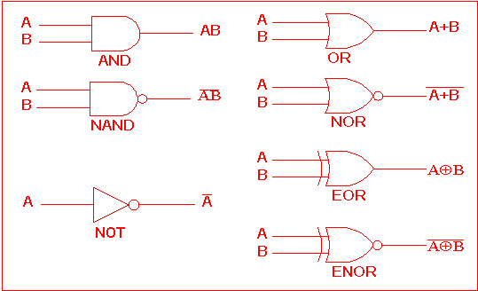

**Your answer below**

|  |
| --- |
| AND – The AND gate takes two or more inputs and returns a positive output if both inputs are positive.  OR – The OR gate takes two or more inputs and returns a positive output if one of the inputs is true.  NAND – NAND stands for ‘NOT AND’ and this gate takes the output returned by the AND gate as input and inverts the output.  NOR – NOR stands for ‘NOT OR’ and this gate takes the output returned by the OR gate as input and inverts the output.  NOT – The NOT gate returns the inversion/opposite of the given input.  EOR – EOR stands for ‘Exclusive OR’ and this gate takes in two inputs and returns a positive input if only one of the inputs is positive.  ENOR – The ‘Exclusive NOT OR’ gate takes in two inputs that is positive at the EOR gate and inverts the output. |

**Marker’s Comments**

|  |
| --- |
|  |

**4. List the seven laws of Boolean algebra [7 Marks](7 SO: 3 AC: 1)**

**Your answer below**

|  |
| --- |
| * Annulment Law * Identity Law * Idempotent Law * Complement Law * Commutative Law * Double Negation Law * de Morgan’s Theorem |

**Marker’s Comments**

|  |
| --- |
|  |